

**Customer Retention Project**

Submitted by: Moncy Kurien

**ACKNOWLEDGMENT**

References:

1. Data description
2. Use case document.

# INTRODUCTION

## ● Business Problem Framing

Customer satisfaction is the most important factor, that guarantees the success of an online store. In this project, we will be exploring the different factors that ensures customer satisfaction and retention.

## ● Conceptual Background of the Domain Problem

Customer satisfaction has emerged as one of the most important factors that guarantee the success of online store it has been positioned as a key stimulant of purchase repurchase intentions and customer loyalty a comprehensive review of the literature theories and models have been carried out to propose the models for customer activation and customer retention.

5 major factors that contributed to the success of an ecommerce store have been identified as: service quality, system quality, information quality, trust and net benefit.

The research furthermore investigated the factors that influence the online customers repeat purchase intention.

The combination of utilitarian value and head and stick values are needed to affect the repeat purchase intention positively.

## ● Motivation for the Problem Undertaken

Customer satisfaction and retention is the key for any online shopping sites. in this problem we will be exploring the data set do you find out the different factors that affect customer satisfaction and help the company to take decisions for successful customer retention.

# Analytical Problem Framing

## **●** Data Sources and their formats

There are 2 sheets [one is detailed] and second is encoded in the excel file. You may use any of them by extracting in separate excel sheet. The number of columns is more than 47. Read the column header carefully. The data sets and figures are highly confidential. Any kind of commercial activities found with the content will be taken strict action the data set is only available for academic purpose.

## **●** Data Preprocessing Done

There are no missing values in the data. No cleaning done in the data set.

## **●** Data Inputs- Logic- Output Relationships

**○** All the columns except the column with zip codes are objects. The column with the zip codes is an integer.

## ● Hardware and Software Requirements and Tools Used

1. Google Colab
2. MATPLOTLIB
3. SEABORN
4. PANDAS
5. NUMPY

## **● Visualizations**

**Distribution of the genders in the customers population**

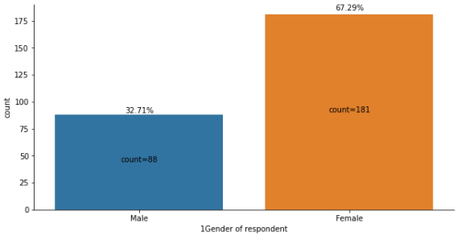

Observations:

* The dataset contains more female respondents than male.

**Distribution of Age ranges of the customers**

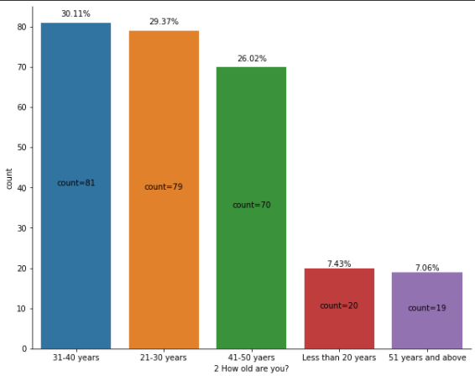

**Observations:**

* Most of the respondents are in the age groups of 30s, 20s and 40s as 1st, 2nd and 3rd places.
* The age groups less than 20 and 51 and above are very less.

**Distribution of customers from each city:**

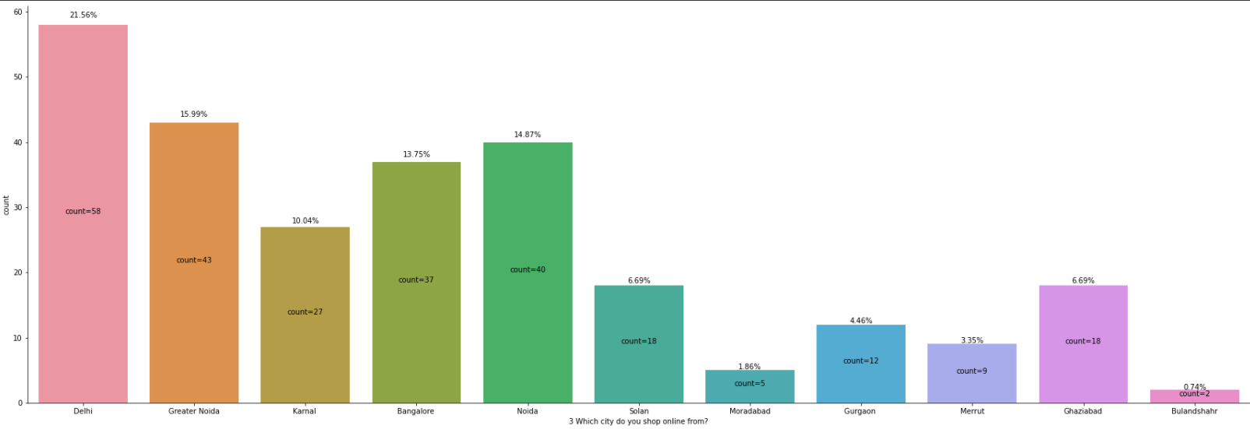

**Observations:**

* Among the available cities, Delhi has the highest number of respondents followed by Greater Noida, Noida, Banglorein the subsequent places.
* Bulandshahr has the lowest number of respondents.

**Customers’ online shopping age**

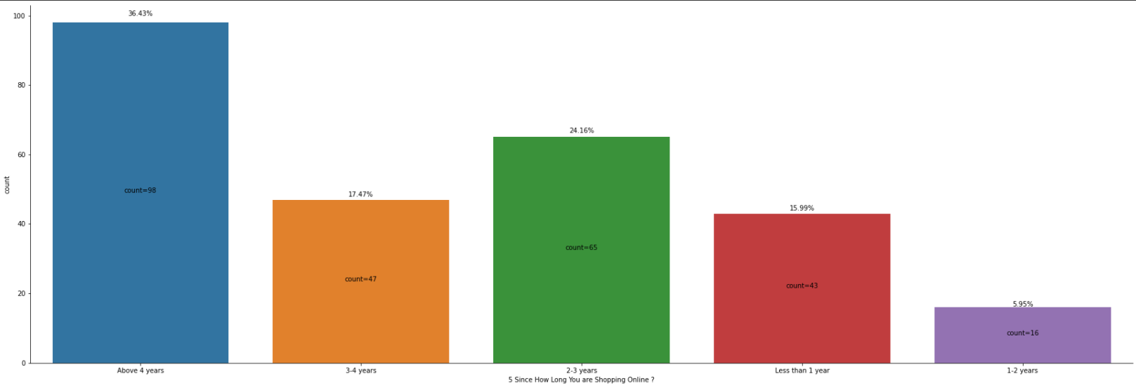

**Observations:**

* The data shows that Most of the customers are using online shopping for more than 4 years. This indicates that there is many repeat customers.
* There is also an increased number of customers using online shopping within 1 year than customers using online shopping for 1-2 years. This indicates that online shopping is getting popular again recently although there was a slight decrease in the 1-2 years' population.

**Devices used to access the online stores:**

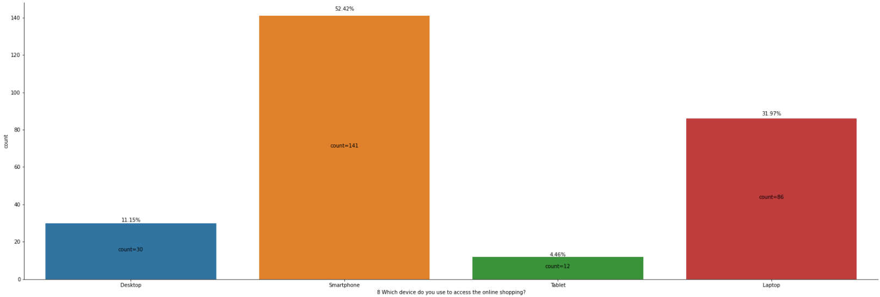

**Observations:**

1. Smartphone is the most used device to visit online shopping stores. About 52% of the customers use smartphone to visit the store.

**Distribution of campaign platforms**

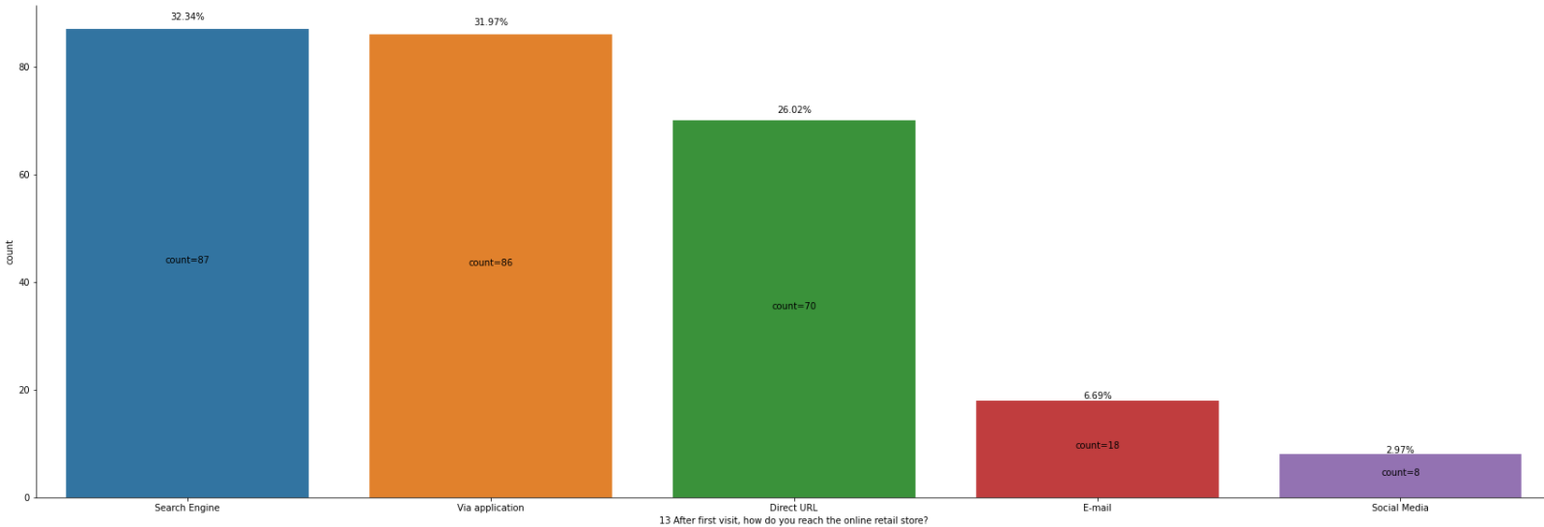

**Observations:**

1. The repeat customers are using Search engines and applications to come back to the online stores after.
2. Social media channel is the least used channel.

**Preferred modes of payment**

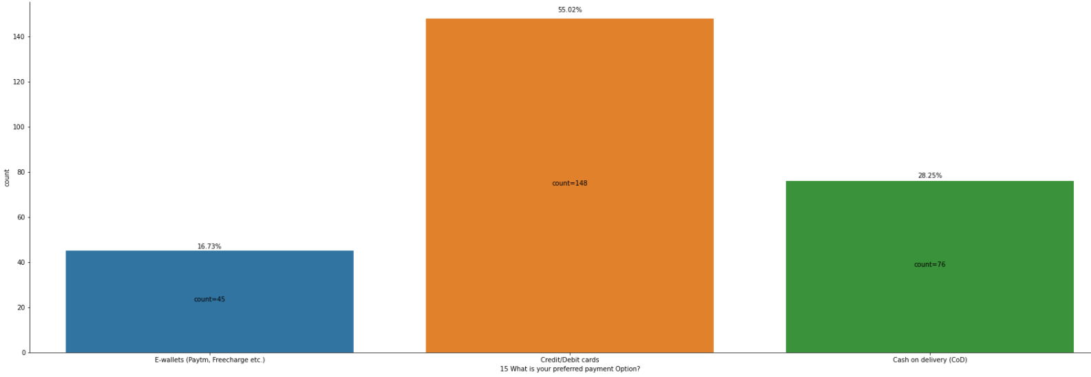

**Observations:**

* For about 55% of the customers the preferred payment option is Credit/Debit cards.
* E-wallets are still the least preferred option.

**Online Shopping sites used by the customers:**

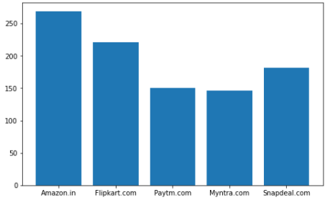

**Observations:**

* Most of the customers are using Amazon websites followed by Flipkart and Snapdeal.
* Myntra is the least used site.

**Sites that are easy to use**

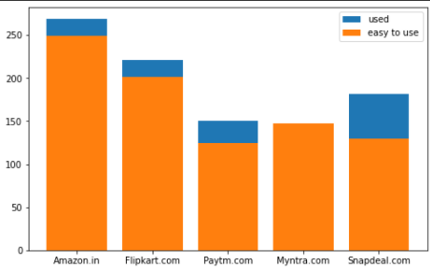

**Observations:**

* Most of the customers feel that Amazon is the easiest to use web store followed by Flipkart.
* Though many customers are using Snapdeal, not many customers feel that Snapdeal is an easy-to-use site.

**Online sites that are visually good**

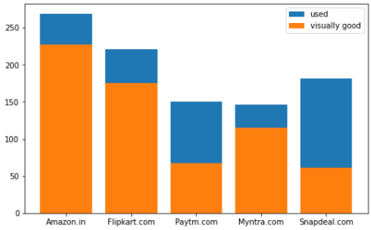

**Observations:**

* Amazon is considered as the most visually appealing site.
* Snapdeal and Myntra are the least visually appealing sites.
* The most percentage of customers of the Myntra site seem to like its visual aspects than any other sites.

**Sites that have wide variety of products:**

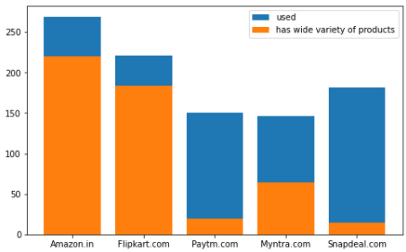

**Observations:**

1. Most of the customers feel that the Amazon site has the wide variety of products on offer followed by Flipkart.
2. Snapdeal and Paytm sites have the least variety of products.

**Sites that have relevant description information of Products**

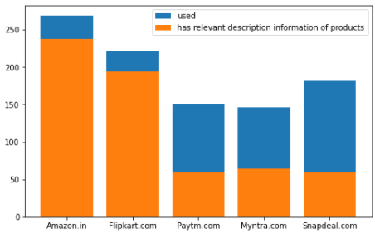

**Observations:**

1. Most of the customers think that Amazon and Flipkart sites have the most relevant information on products on the site.
2. Snapdeal has the least percentage of people thinking that the site has relevant information on products on the site.

**Sites that are fast**

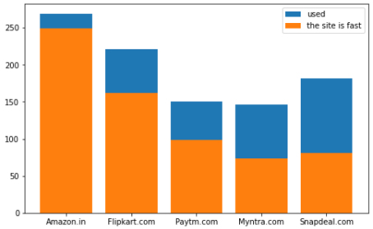

**Observations:**

1. Most customers think that the Amazon site is fast.
2. Only very less percentage of customers feel that the Snapdeal site is fast.

**Reliable sites**

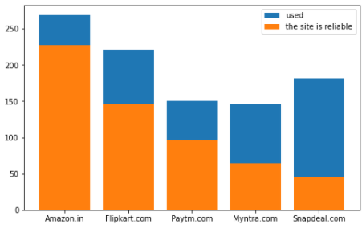

**Observations:**

* Amazon is the most reliable site as per the survey.
* Snapdeal is the least reliable site as per the survey.

**Sites with Several payment options**

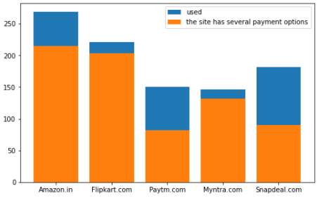

**Observations:**

1. Most of the customers feel that Amazon has several payment options.
2. Percentagewise, most percentage of customers that used Myntra feel that it has several payment options followed by Flipkart.
3. Most of the customers that used Snapdeal feel that it does not have several payment options.

**Sites with secure financial information:**

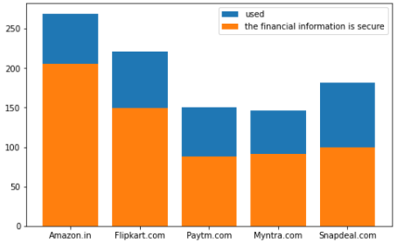

**Observations:**

1. Per the survey, the customers feel that the Amazon site has the most security for financial information.
2. The customers feel that the least secure site is the Paytm site.

**Sites with perceived trustworthiness**

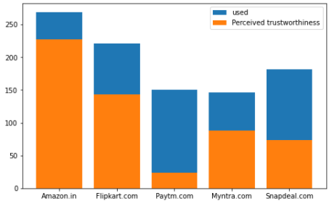

**Observations:**

1. The most trustworthy site is Amazon.
2. The least trustworthy site per the survey is Paytm.

**Sites with Longer delivery period**

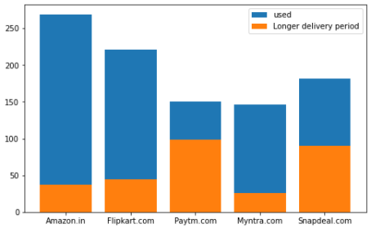

**Observations:**

* Paytm and Snapdeal have the longest delivery periods.
* Most of the Amazon customers feel that the site has a reasonable delivery period.

**Sites used vs Sites recommended:**

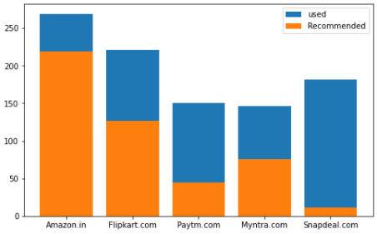

**Observations:**

* Amazon is the most recommended store followed by Flipkart.
* Snapdeal is the least recommended store though it is used by more customers than Paytm and Myntra.

## **CONCLUSION**

### ● Key Findings and Conclusions of the Study

○ We can clearly see that the customers are satisfied with the site when the site was easy to use, the visuals are good, the site has a wide variety of products, contains good information about the products, the site is fast and reliable, have several payment options, is secure and trustworthy and has a shorter delivery period.

○ The most popular payment option is the credit/debit card. Cash on delivery is the second most popular payment option.

### ● Learning Outcomes of the Study in respect of Data Science

○ The visualization revealed some important behaviours of the customers.

### ● Limitations of this work and Scope for Future Work

○ The biggest limitation is that there are only 269 records for analysis. The lack of sample data for analysis means that the observation could differ when we analyse more data from the same population. As a future scope, more data can be extracted from the surveys and analysed. Getting real time data will be effective.